Bahria University,

Karachi Campus



LAB EXPERIMENT NO.

**03**

LIST OF TASKS

|  |  |
| --- | --- |
| TASK NO | OBJECTIVE |
| 1 | **Implement the EDA steps on the provided dataset in the Class using Python.** |
| 2 | **Implement the EDA steps on the provided dataset in the Class using KNIME.** |
| 3 | **Perform the complete Exploratory Data Analysis on iris dataset using Python.** |

**Task 1: Implement the EDA steps on the provided dataset in the Class using Python.**

**Solution:**

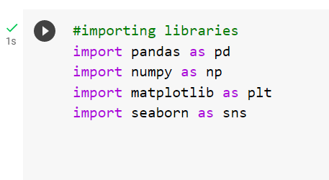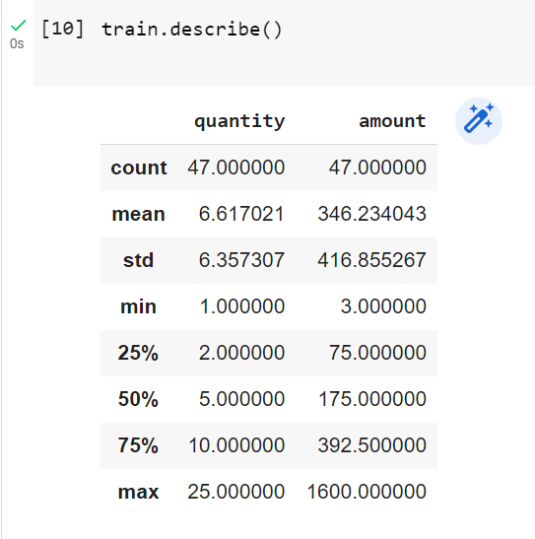

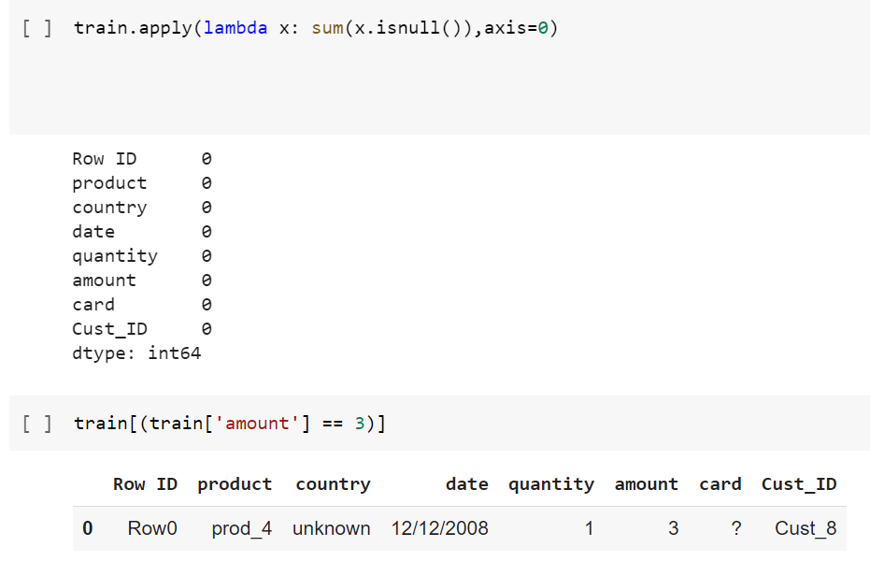

**Task 2: Implement the EDA steps on the provided dataset in the Class using KNIME.**

**Solution**

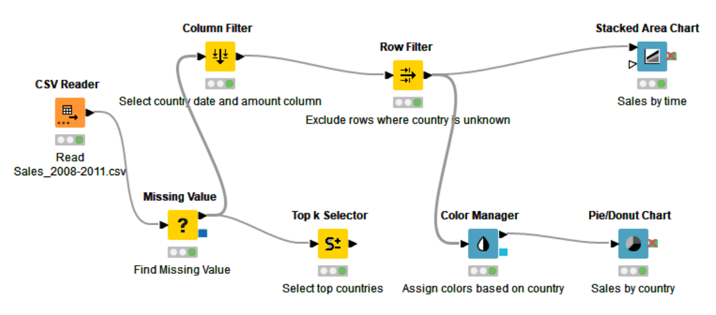

**Output**

**Task 3: Perform the complete Exploratory Data Analysis on iris dataset using Python.**

**Solution:**

